Course information: CS008 Web design

Aaron Zhang & Anyi Huang

Assignment: Final Project

Group Final Project

Version <Final>

Table Of Contents

Time Log 3

Introduction 4

Purpose 4

Definitions, acronyms, and abbreviations 4

Overall Description 4

Story Board 5

Specific requirements 6

|  |  |  |  |
| --- | --- | --- | --- |
| Time Log | | | |
| Estimated time to complete assignment => | | | 30 Hours |
| Date | Time Spent  (in hours) | Description | Author |
|  |  | First Version of Software Requirements |  |
| 11/20 | 1 | Design | Aaron & Anyi |
| 11/20 | 3 | Build basic structures (top, nav, footer, background etc.) | Aaron |
| 11/20 | 2 | Search for pictures and adjust them | Anyi |
| 11/21 | 1 | Code home page | Anyi |
| 11/21 | 3 | Code reservation and contact page | Aaron |
| 11/22 | 1 | Add validation to forms | Aaron |
| 11/23 | 2 | Make menu page | Aaron & Anyi |
| 11/24 | 3 | Code CSS file | Aaron & Anyi |
| 11/27 | 1 | Add text content | Anyi |
| 11/28 | 3 | Check and adjust CSS and functionality | Aaron |
| 11/28 | 1 | Adjust shown content of forms | Anyi |
| 12/4 | 1 | Do final adjustment and test | Aaron & Anyi |
| 12/6 | 1 | Adjust codes through html and css validator | Aaron |
| 12/8 | 1 | Presentation in CS Fair | Aaron & Anyi |
|  |  |  |  |
|  |  |  |  |
|  |  |  |  |
|  |  |  |  |
|  |  |  |  |
|  |  |  |  |
|  | 24 | <=Total Time Spent |  |
|  |  |  |  |

# Introduction

### Purpose

The purpose of this document is to describe the requirement specification for the web site “http://zzhang24.w3.uvm.edu/cs008/final/home.php”.

The intended audience for this document is the customers of restaurant

*First it is the contract between you and the client. Second it is for the developer of the site. Two primary goals are:*

1. *Client gets a very good understanding of what you will be delivering.*
2. *Developer has a very good understanding of what they are going to create.*

### Definitions, acronyms, and abbreviations

*Sample for the client:*

ER Diagram – a diagram to represent the data you want to save with your system

W3 Validation – refers to both Html and CSS validation tool provided by the W3c.org. the html validator is located at:

<http://validator.w3.org/>

with the CSS validator located at:

<http://jigsaw.w3.org/css-validator/>

# Overall Description

This a website of Sichuan cuisine restaurant. Generally, we have five pages which is home, menu, reservation, contact us and about us. Under menu page, we have three separated pages because we provide three types of Sichuan cuisine and they read data from csv files. The home page is brief introduction of Sichuan cuisine, also includes a link to the documentary A Bite of China. The menu page uses three images to be the entrances of different menus. We added hover effect (overlay) on image. The reservation page and contact us page use similar technique codes which is form. We add validation to both of them. The only difference is we would send a confirmation to customers if they click on submit button. But in contact us page we will not send an email confirmation to customers, we would only show “We will reply your message within 24 hours.” The data from these two pages would be stored in two separated csv files in background. The about us page is the brief introduction about this restaurant and the group that it belongs to.

We made some designs in the body background and header. We applied animated images in menu pages to make customers desire to eat in our restaurant.

# Story Board

A close up of a map

Description generated with very high confidenceA flock of white map

Description generated with high confidence

# Specific requirements

1. *You fill out* – This is where you would put the exact detail of what you want for the project. For example:
2. *Title for main page*: *FastChuan*
3. *Meta Description*: *A website of a Sichuan cuisine restaurant*
4. *Meta Character set*: UTF - 8
5. *Logo*: 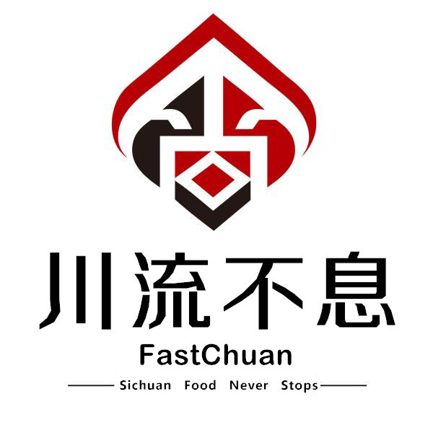
6. *Main page photo*: 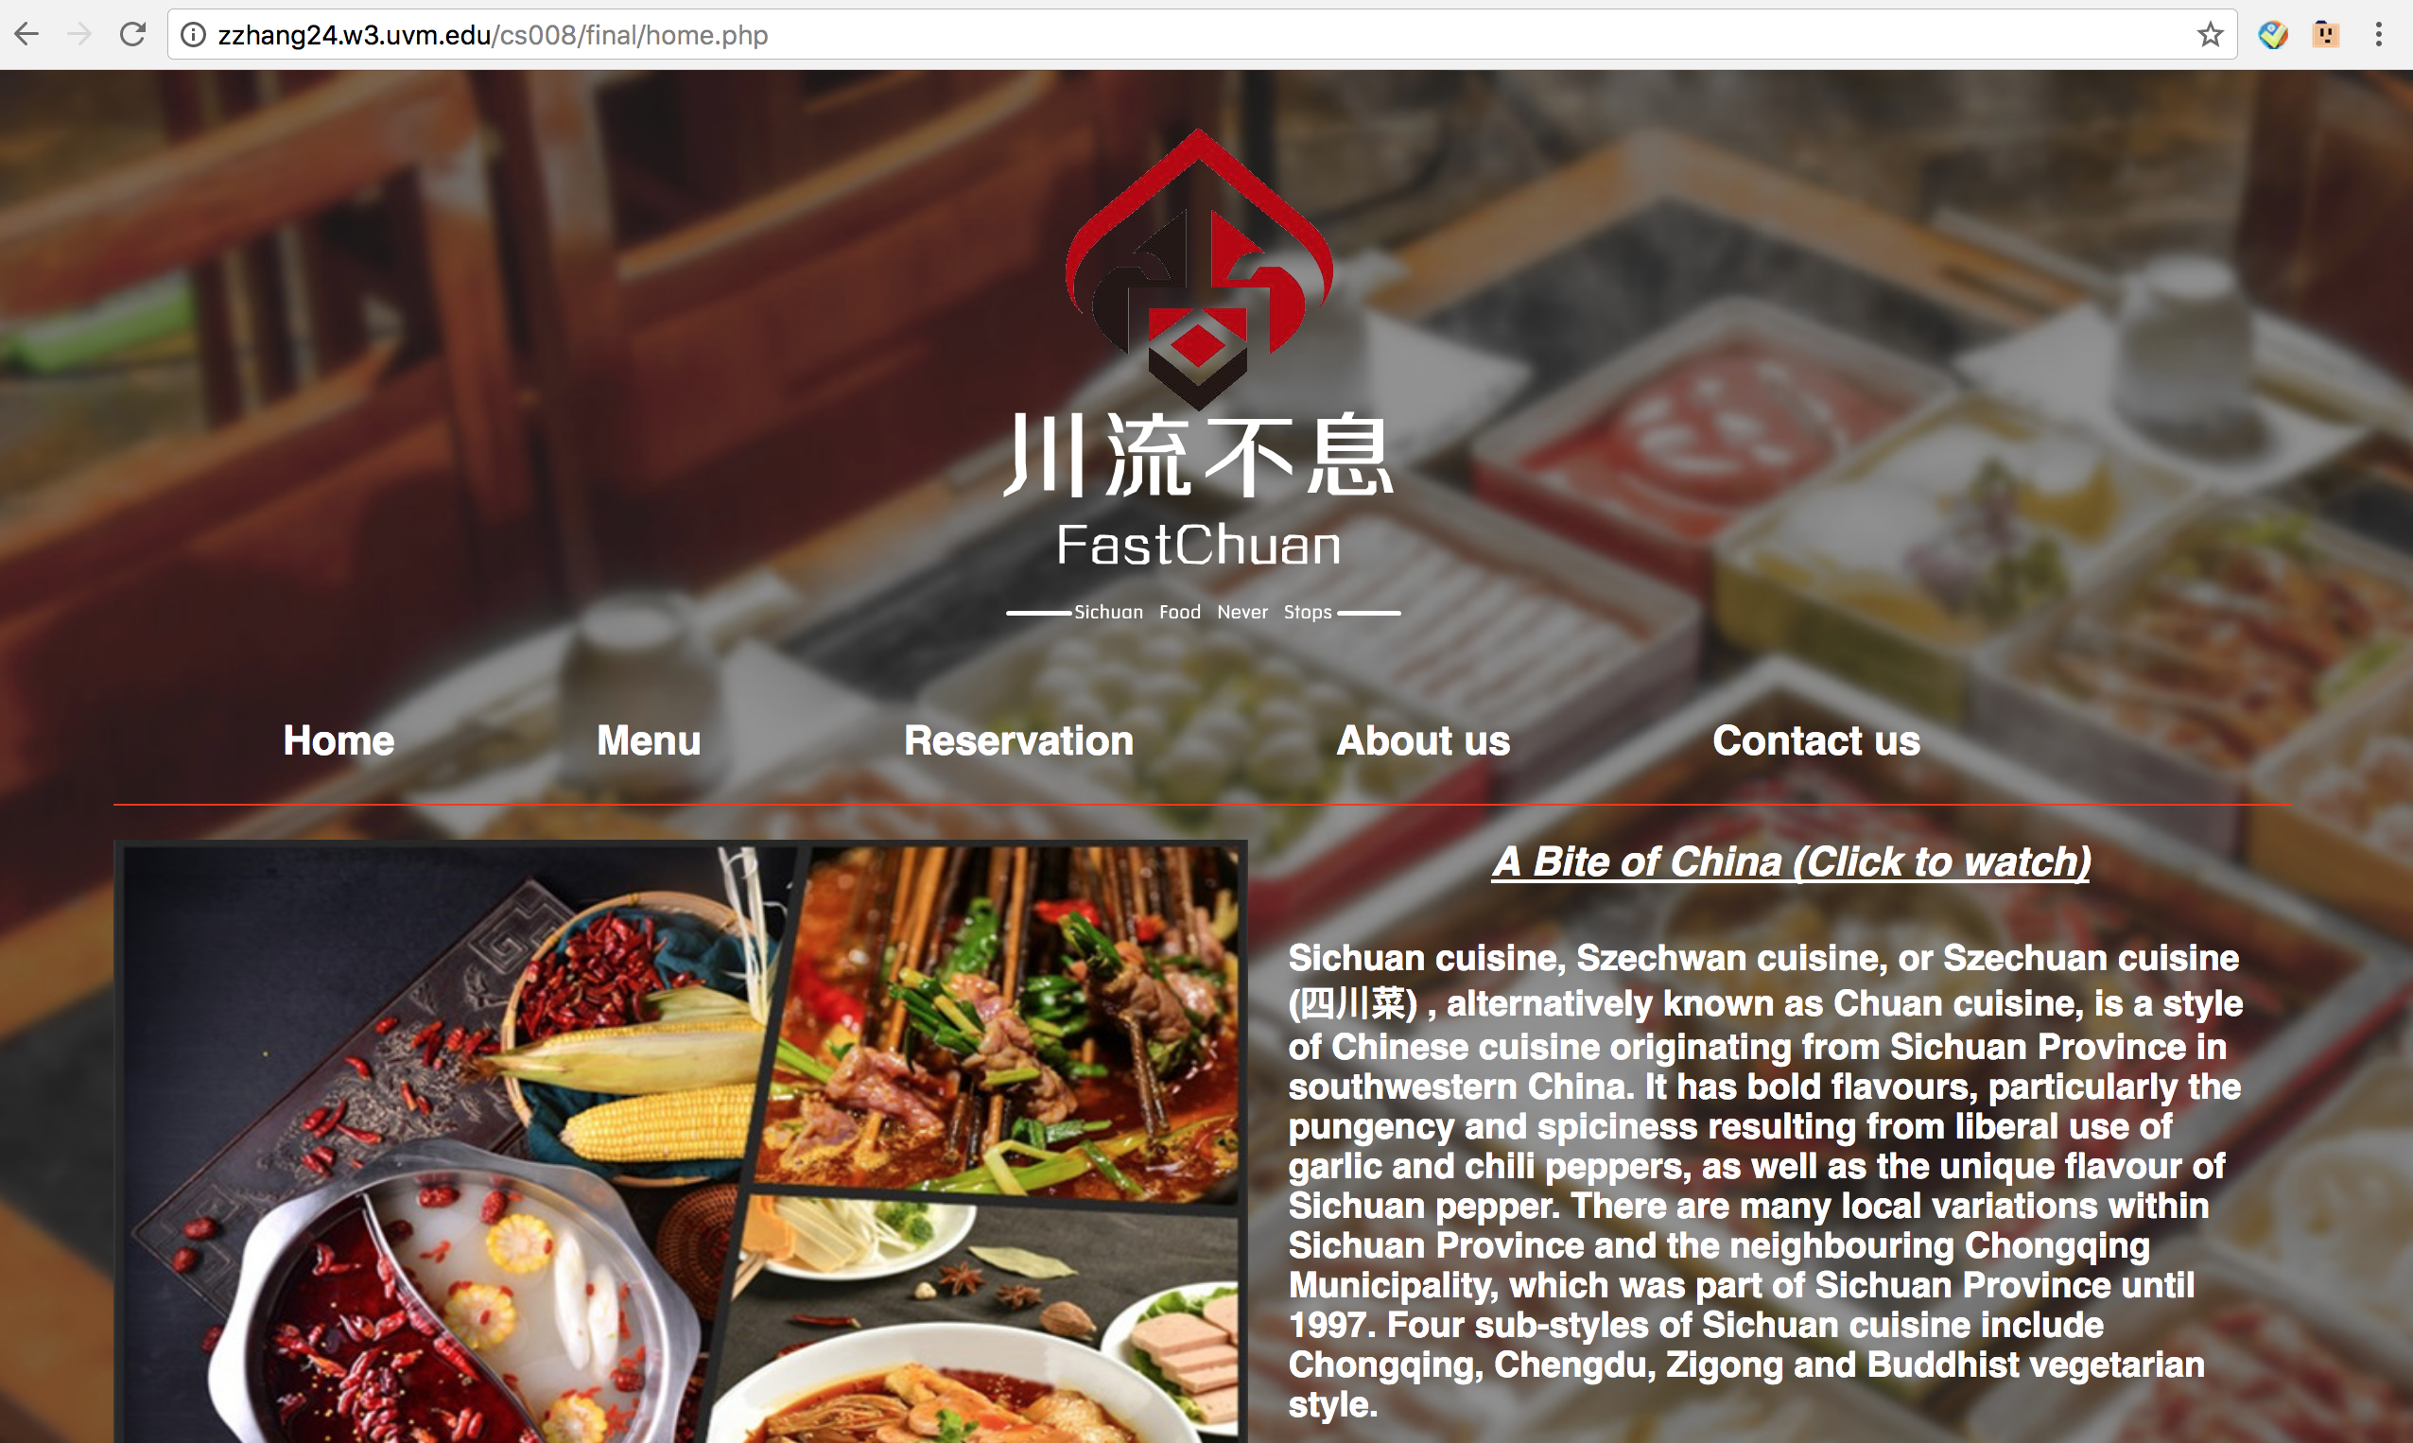
7. *Content can be found here*:

Sichuan cuisine, Szechwan cuisine, or Szechuan cuisine (四川菜) , alternatively known as Chuan cuisine, is a style of Chinese cuisine originating from Sichuan Province in southwestern China. It has bold flavours, particularly the pungency and spiciness resulting from liberal use of garlic and chili peppers, as well as the unique flavour of Sichuan pepper. There are many local variations within Sichuan Province and the neighbouring Chongqing Municipality, which was part of Sichuan Province until 1997. Four sub-styles of Sichuan cuisine include Chongqing, Chengdu, Zigong and Buddhist vegetarian style.

Sichuan in the Middle Ages welcomed Near Eastern crops, such as broad beans, sesame and walnuts. Since the 16th century, the list of major crops in Sichuan has even been lengthened by New World newcomers. The characteristic chili pepper came from Mexico, but probably overland from India or by river from Macao, replacing the spicy peppers of ancient times[citation needed] and complementing the Sichuan peppercorn (花椒; huājiāo). Other newcomers from the New World included maize (corn), which largely replaced millet; white potatoes introduced by Catholic missions; and sweet potatoes. The population of Sichuan was cut by perhaps three quarters in the wars from the Ming dynasty to the Qing dynasty. Settlers from the adjacent Hunan Province brought their cooking styles with them.

Sichuan is colloquially known as the "heavenly country" due to its abundance of food and natural resources. One ancient Chinese account declared that the "people of Sichuan uphold good flavour, and they are fond of hot and spicy taste." Most Sichuan dishes are spicy, although a typical meal includes non-spicy dishes to cool the palate. Sichuan cuisine is composed of seven basic flavours: sour, pungent, hot, sweet, bitter, aromatic and salty. Sichuan food is divided into five different types: sumptuous banquet, ordinary banquet, popularised food, household-style food and food snacks. Milder versions of Sichuan dishes remain a staple of American Chinese cuisine.

The complex topography of Sichuan Province, including its mountains, hills, plains, plateaus and the Sichuan Basin, has shaped its food customs with versatile and distinct ingredients.

Sichuan cuisine often contains food preserved through pickling, salting and drying. Preserved dishes are generally served as spicy dishes with heavy application of chili oil.

The most unique and important spice in Sichuan cuisine is the Sichuan pepper (花椒; *huājiāo*; "flower pepper"). Sichuan peppercorn has an intense fragrant, citrus-like flavour and produces a "tingly-numbing" (麻; *má*) sensation in the mouth. Other commonly used spices in Sichuan cuisine are garlic, chili peppers, ginger and star anise.

Broad bean chili paste (豆瓣酱; 豆瓣醬; *dòubànjiàng*) is one of the most important seasonings.It is an essential component to famous dishes such as Mapo tofu and double-cooked pork slices. Sichuan cuisine is the origin of several prominent sauces/flavours widely used in modern Chinese cuisine, including: *Yuxiang* (魚香); *Mala* (麻辣); *Guaiwei* (怪味). Common preparation techniques in Sichuan cuisine include stir frying, steaming and braising, but a complete list would include more than 20 distinct techniques. (Referenced from Wiki Pedia)

1. I hope you get the idea. The goal would be the developer would be able to make the entire site based on this document and the client would see you have included everything.